**FRIO COUNTY COMMISSIONERS COURT MINUTES FOR**

**Regular Meeting April 11th, 2023**

On the 11th day of April, 2023, at 3:00 p.m., the Commissioners Court of Frio County met in a regular meeting with the following members either absent or present, to-wit: Rochelle Lozano Camacho, Frio County Judge was absent; Joe Vela, Commissioner Pct 1 present; Mario Martinez, Commissioner Pct 2 present; Raul Carrizales, Commissioner Pct 3 present; Danny Cano, Commissioner Pct 4 present; Joseph A. Sindon, Legal Counsel for Frio County Commissioners Court present; and Aaron Ibarra, Frio County Clerk present when the following meeting was held, to-wit:

I. Invocation and Pledge of Allegiance

II. Adopt Agenda

**MOTION: COMMISSIONER MARTINEZ**

**SECOND: COMMISSIONER CANO**

**MOTION PASSED**

III. Old Business- **NONE**

**PRESENTATION**

**ACTION AGENDA ITEMS**

IV. General Discussion- **Mr. Garcia spoke about the vacant engineer position.**

V. Citizens To Be Heard- **NONE**

VI. New Business

**PRESENTATION**

**ACTION AGENDA ITEMS**

(1) Hon. Rochelle Camacho, Frio County Judge, requests:

Consider/take action on designating April as being Child Abuse Prevention Month.

**MOTION: COMMISSIONER VELA**

**SECOND: COMMISSIONER CANO**

**MOTION PASSED**

(2) Hon. Rochelle Camacho, Frio County Judge, requests:

Consider/take action on approving the county to pay Trevino Royal Oaks Funeral Chapels for the indigent cremation for Eugene Aguilar.

**MOTION: COMMISSIONER MARTINEZ**

**SECOND: COMMISSIONER CANO**

**MOTION PASSED**

**THE AGREED UPON PRICE IS $850.00**

(3) Hon. Ofilia M. Trevino, Frio County District Clerk, requests:

Consider/take action on agreeing to use funds previously paid by the Office of the Attorney General of Texas (OAG) Child Support Division pursuant to an Interlocal Cooperation Contract Between the Office of the Attorney General and Frio County, to fund the remainder of the contract term, which lasts until August 31, 2024.

**MOTION: COMMISSIONER MARTINEZ**

**SECOND: COMMISSIONER VELA**

**MOTION PASSED**

(4) Hon. Danny Cano, Frio County Commissioner, Precinct No. 4, requests:

4.1 Consider/take action on entering into an Interlocal Agreement Between the Frio County and the City of Dilley for animal control services.

4.2 If the agreement is approved, consider/take action on approving a resolution authorizing Hon. Rochelle Camacho to sign same on behalf of Frio County.

**NO ACTION TAKEN**

(5) Ramiro Trevino, Frio County Human Resources Director, requests:

Discussion on probation period pertaining to employee benefits.

**ITEMS WERE DISCUSSED ABOUT POTENTIALLY REDUCING THE WAIT PERIOD, OR WHAT IS POSSIBLE WHEN NO JUSTIFICATION IS PROVIDED, IN THE END IT WAS AGREED THAT EVERY EMPLOYEE SHOULD JUST ABIDE BY THE CURRENT HANDBOOK AND ITS RULES.**

(6) Ramiro Trevino, Frio County Human Resources Director, requests:

Remove Pete Martinez as temporary Sick Leave Pool Administrator and appoint newly hired Frio County Human Resources Director, Ramiro Trevino, as the new Sick Leave Pool Administrator.

**MOTION: COMMISSIONER MARTINEZ**

**SECOND: COMMISSIONER CANO**

**MOTION PASSED**

(7) Hon. Mike Morse, Frio County Sheriff, requests:

Discuss and approve the damaged property request submitted by Hillman Land and Cattle.

**MOTION: COMMISSIONER MARTINEZ**

**SECOND: COMMISSIONER CANO**

**MOTION PASSED**

(8) Tommy Navarro, Frio County Facilities Management Supervisor:

Discuss/update by Sandoval Contracting Inc, and Steve J. Patmon, Architect (SJPA) regarding the progress of the Frio County Building Improvement Project located at 1796 IH 35 E, Pearsall, Texas.

**ITEM WAS DISCUSSED AT LENGTH INVOLVING THE CURRENT SITUATION OF THE PROJECT.**

(9) Hon. Crystal Marquez, Frio County Auditor, requests:

9.1 Consider / take action to approve the budget amendments to the FISCAL YEAR 2022-2023 Frio County Budget, list below:

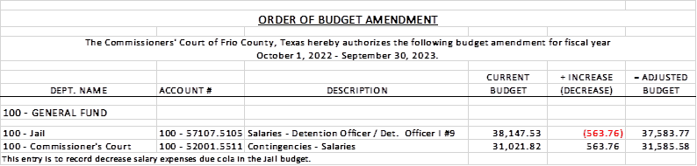

9.2 If the amendment is approved, consider/take action on signing order stating same.

**MOTION: COMMISSIONER CANO**

**SECOND: COMMISSIONER MARTINEZ**

**MOTION PASSED**

(10) Hon. Crystal Marquez, Frio County Auditor, requests:

10.1 Consider / take action to approve the budget amendments to the FISCAL YEAR 2022-2023 Frio County Budget, list below:

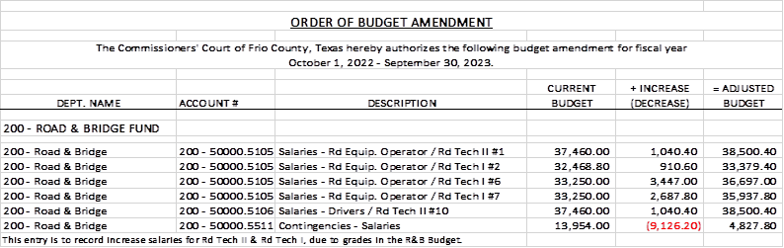

10.2 If the amendment is approved, consider/take action on signing order stating same.

**MOTION: COMMISSIONER MARTINEZ**

**SECOND: COMMISSIONER VELA**

**MOTION PASSED**

(11) Hon. Crystal Marquez, Frio County Auditor, requests:

11.1 Consider / take action to approve the budget amendments to the FISCAL YEAR 2022-2023 Frio County Budget, list below:

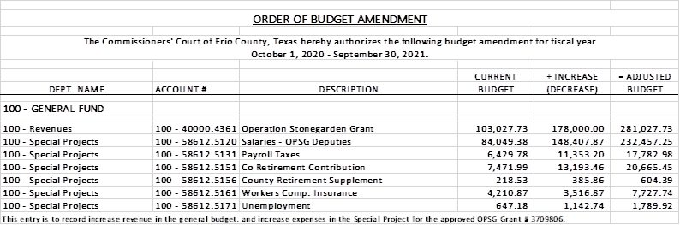

11.2 If the amendment is approved, consider/take action on signing order stating same.

**MOTION: COMMISSIONER CARRIZALES**

**SECOND: COMMISSIONER MARTINEZ**

**MOTION PASSED**

(12) Hon. Crystal Marquez, Frio County Auditor, requests:

Consider / take action on approving engineering fees to Medina Electric for two safety lights at the Hilltop Subdivision in Dilley, Texas for a cost of $100.00 each. Exact locations are as follows:

* Corner of CR 4603/Barbra St. & CR 4604/Russel Rd. – Engineering Fee
* Corner of CR 4602/Justin Rd. & IH 35 – Engineering Fee

**MOTION: COMMISSIONER CANO**

**SECOND: COMMISSIONER VELA**

**MOTION PASSED**

(13) Hon. Crystal Marquez, Frio County Auditor, requests:

13.1 Consider/take action to approve a Software as a Service Renewal Agreement between Frio County and Kologik, LLC for the provision of law enforcement software for the Frio County Sheriff’s Department.

13.2 If the agreement is approved, consider/take action on signing a resolution authorizing Hon. Rochelle Camacho to enter into same on behalf of Frio County.

**MOTION: COMMISSIONER MARTINEZ**

**SECOND: COMMISSIONER CANO**

**MOTION PASSED**

(14) Ancelmo Ornelas, Frio County Road and Bridge Administrator, requests:

Consider/take action on approving reimbursement of the park rental fee to Victoria Rangel, for a fundraiser held on April 2, 2023 at Fireman’s Park for Matthew Gonzales for medical expenses.

**MOTION: COMMISSIONER CANO**

**SECOND: COMMISSIONER MARTINEZ**

**MOTION PASSED**

(15) Ancelmo Ornelas, Frio County Road and Bridge Administrator, requests:

15.1 Discuss approving the amended final subdivision plat for the Sendero Ridge Ranch Subdivision to be filed for record in the Frio County Clerk’s Office. Specifically, discuss whether the requirements of the Fifth Revised Edition of the Frio County Standards for Subdivisions have been met.

15.2 If all requirements have been met, sign resolution stating same, then authorize the filing and recording of the plat with the Frio County Clerk after proper acknowledgment.

**MOTION: COMMISSIONER MARTINEZ**

**SECOND: COMMISSIONER VELA**

**MOTION PASSED**

(16) Ancelmo Ornelas, Frio County Road and Bridge Administrator, requests:

Discuss/take action on approving sealcoat quotes for the following county roads - CR 2755 (Dennis Rd), CR 2756 (Thomas Rd) & CR 2750 (Whitaker Rd).

**MOTION: COMMISSIONER MARTINEZ**

**SECOND: COMMISSIONER CANO**

**MOTION PASSED**

(17) Frio County Commissioners Court, requests:

Receive in person from the following county officials the following reports as mandated by law:

17.1 Presentation by Frio County Treasurer of detailed report as mandated by Section 114.026, Local Government (“Code”) (this report is to be presented at each **regular term of commissioners court).**

17.2 Frio County Treasurer to exhibit the books and accounts of that office for the inspection of the commissioners court (**to be done at each regular term of commissioners court).**

17.3 Consider/take action on authorizing the execution by Frio County Commissioners Court (the Judge and each commissioner) of an affidavit stating the requirements of the treasurer’s report have been met as mandated by section 114.026 of the Code.

17.4 Consider/take action on execution of an order of the commissioners court approving the county treasurer’s report and order their publication in the Frio-Nueces Current as mandated by Section 114.026 of the Code or publication on the county’s website.

**MOTION: COMMISSIONER CARRIZALES**

**SECOND: COMMISSIONER VELA**

**MOTION PASSED**

(18) Frio County Commissioners Court requests:

Presentation, pursuant to Section 114.044 of the Local Government Code, by:

1. Frio County District Clerk;

2. Frio County Clerk

3. Frio County Treasurer

4. Frio County Attorney

5. Frio County Judge

6. Frio County Sheriff

7. Frio County Auditor

8. Frio County Justice of the Peace

9. Frio County Constables

**(who collects or handles any money for the use of the county) of all fines imposed, judgments rendered and collected, and all jury fees collected by the respected courts in favor of or for the use of the county and at that time when the reports are presented to present receipts vouchers that show disposition of the money, fines or judgments.**

After examination by the commissioners court as to the correctness of the reports, consider/action on directing the county clerk to enter information in county finance records as mandated by Section 114.044 of the Code.

**MOTION: COMMISSIONER MARTINEZ**

**SECOND: COMMISSIONER CANO**

**MOTION PASSED**

**LET IT BE NOTED THAT CONSTABLE 1, AND JP4 DID NOT SUBMIT A REPORT**

(19) Documents (resolutions, orders, contracts, etc.) to be signed.

**REVIEWED AND SIGNED**

(20) Allow bills payable

**MOTION: COMMISSIONER MARTINEZ**

**SECOND: COMMISSIONER VELA**

**MOTION PASSED**

(21) Adjourn

**MOTION: COMMISSIONER CARRIZALES**

**SECOND: COMMISSIONER MARTINEZ**

**MOTION PASSED**

**APPROVED:**

**_____________________________________  
  
_____________________________________  
  
_____________________________________  
  
_____________________________________  
  
_____________________________________**